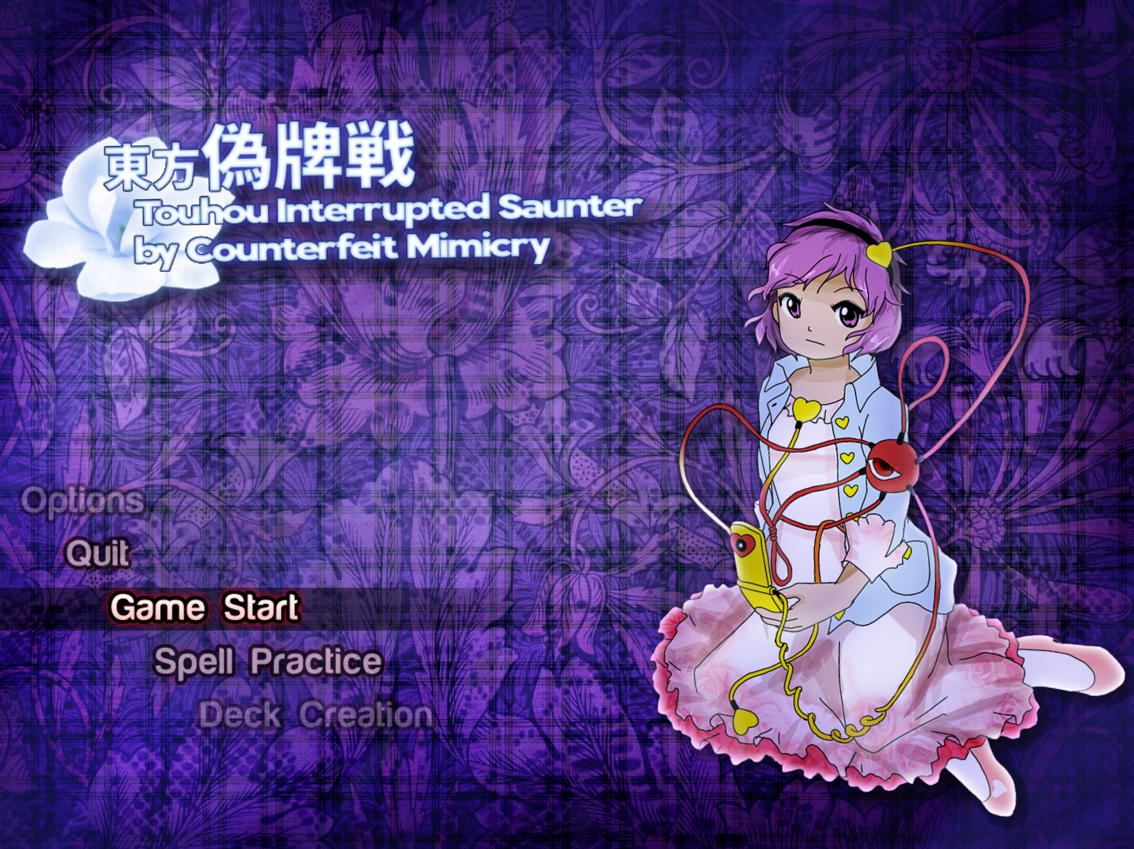

| **Touhou 偽牌戦 - Interrupted Saunter by Counterfeit Mimicry Developer: zino** |
| --- |

Generally speaking I felt this was a good game to start with given the president of the contest and I feel in general it contains a lot of the positives and negatives I’ve seen within each entry in some regard.

The system inspired by Hisoutensoku I do think is pretty neat… BUT I do feel it suffers in two distinct ways:

1. Gaining power to fill up the meter feels very slow. Primarily compounded by how small power numbers feel in being obtained as well as how short the stage portion of this entry is.
2. Cost and activation isn’t really made clear in terms of how things work. It took me a bit to discover that shottype cards only activated for focused/unfocused movement depending on what Satori was in at the time.

It’s a real shame because I can definitely see something like this really being fleshed out to give a lot of customizability to a playthrough and a lot of these options are really neat. Granted I do feel some of these options do fly in the fact of the contest theme. Particularly the Archer Doll, SP Doll and Entropy Arrows come to mind. The latter two aren’t as straight forward but in many ways they can be abused in a way where you may as well say they’re forward focused.  
  
The spell cards themselves are also pretty rough but I do appreciate how very tongue and cheek a majority of them are, particular Haiji’s spell cards really seem to have a lot of thought in them on a stylistic level. It is a pity I feel that most of the spell card solutions don’t really seem to be completely organic and do require finding a solution that isn’t so immediately obvious or discreet but noteworthy. I even feel the implementation of how some spell cards work contributes to jank that probably should’ve been cleaned up a bit.

Some notable examples being Nether Puppet not being clear in you being able to pass the flames before they become active again (which they’re also pretty fat when activated again) and Eleventh Curse which is a cute idea that I feel loses out on how there’s a noticeable jerk movement when crossing over to a part of the spell card that’s technically on another side of the screen.

I would say that’s generally it though aside from how Belle and Misaki’s non spell comes off as pretty intense the first time around until you’re at least able to make out the lanes on subsequent playthroughs. Every other boss pattern is what I would call pretty sound and honestly I did get a good chuckle out of one of them.

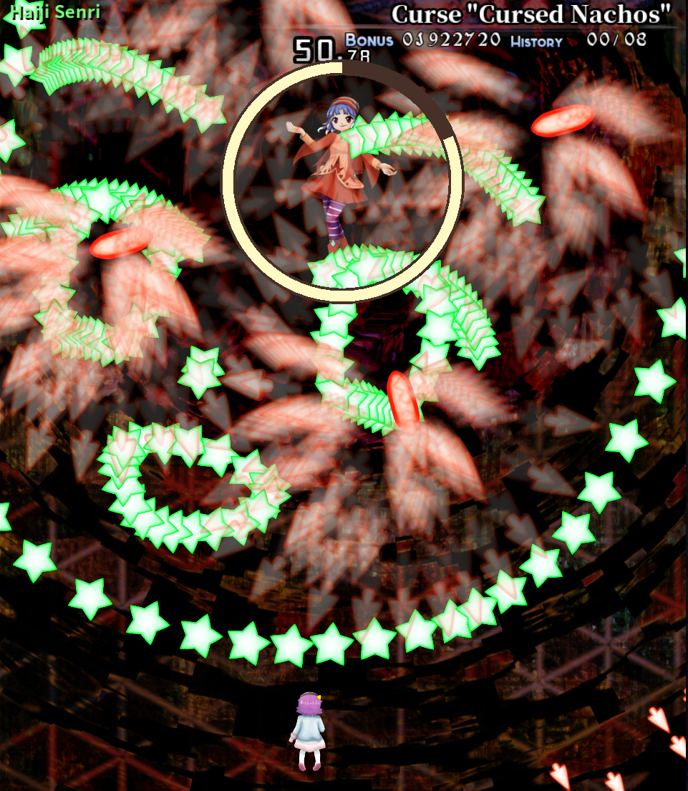

I think we do need more danmaku in the shape of relatively cursed faces.

So the score tally:

| Game Flow | Difficulty | Sound | Control | Quality of Life |
| --- | --- | --- | --- | --- |
| 30 | 25 | 35 | 25 | 45 |

**Game Flow**:  
There is a decent flow here that has some solid basis behind it. Certain areas are rough and powering up is slow but the concept is sound and it’s something I wouldn’t mind seeing further elaboration on. Does have some docked points for not being 100% on theme.  
  
**Difficulty:**

Only one difficulty does make things generally more static. A lot of the early game can feel pretty brutal also if you’re not keeping up with resources and can landslide past that if you’re able to keep a good tab on resources.

**Sound:**  
Generally it sounds like what it should. Sound cues are as they should be and are generally satisfying. If anything I’d even say there probably should be more in knowing when cards have activated.

**Control:**It does follow control to the standards of LuaSTG, however I do feel that having the swap card button on V is slightly awkward. Generally for games like this I’d usually reassign the key to something else like D but it’s something I have to remind myself to not press here. This does carry over to…  
  
**Quality of Life:**

Key binding is not really present as an option within the game, and with how the game has around 5 buttons to use, that does feel like a lost opportunity to try and have players adjust to those inputs with whatever keys they feel comfortable with. Though practice, quick keys and even replays are accounted for here so it’s not a major loss.   
  
Upon thinking more I do appreciate dimming the background as there was some distraction for me looking at the stage background upon initial playthroughs so I’ll appropriate the score for that.

As for the subcategories:

| Sprites/Portraits | User Interface | Aesthetic | Music |
| --- | --- | --- | --- |
| 20 | 20 | 15 | 15 |

**Sprites/Portraits:**Satori’s player sprites convey what they need to for the sake of gameplay. The portraits here though are very well done in mimicking ZUN’s current art style and I feel portray very interesting angles for Satori and Haiji. The OCs of Belle and Misaki also look very nice, which will be shared with another entry as they’re the same portraits. Though I will give a bonus **+10** points for Misaki’s portrait though. I feel purely on a character design level she’s become a favourite to me.

**User Interface:**

If anything it’s relatively dry in terms of presentation but all the info that needs to be conveyed is conveyed in a way that’s clean and effective. Can’t really dock much off for that.

**Aesthetic:**

Not really much of one outside of just mimicking ZUN’s general style and also incorporating Haiji Senri from Len’en into it. Could’ve had maybe a bit more extra in some areas but again, just conveys what it needs to.

**Music:**

I did enjoy Haiji’s theme being rearranged and the title theme does have some good punch to it. I can’t say too much about the other tracks in the game though. The other two to me at least come off as very dry and not really trying to do anything different or crazy. I suppose ultimately that’s fine as I’m not overstimulated but it isn’t something I’ll be listening to on car drives anytime soon.  
  
**Bonus Points: +10**  
  
**Overall:  
240/325  
Around 73% - 74%  
Not bad!**